Technical Meeting Minutes
Adjustable Arm Prosthetic

Meeting Details
Date | 2026-01-24 | Time | 1:00-2:00
Location | Zoom Meeting | Facilitator | Basel Abumailish
Recorder | Basel Abumailish | Meeting Type | Design Review / Technical Progress
Attendees | Basel Abumailish, James Briscoe, Eric Carlos | Optional | N/A
Pre-reads | Previous Weekly Meeting Minutes, Milestone Report 1 | Recording | N/A
Related Tickets |  | Repository | https://github.com/ecarlos03/Senior_Project

Purpose / Objectives
- Review Blender design progress for finger joints and sockets — Basel/ James
- Discuss mechanical limitations identified in finger joint testing — Basel
- Review progress on telescoping rod and structural considerations — James
- Discuss design and layout for forearm — James
- Circuit and coding progress update — Eric
- Had meeting with Professor Han about circuit design saturday from 6-7:30pm - Eric
- Work on Flow chart and schematic diagram for project - Eric
- Work on GitHub links and files - Eric/James

Agenda
- Phase 1 (Design) tasks remain on track
- Finger/hand design is progressing, with focus shifting to ball joint geometry to improve the range of motion
- Forearm and elbow layout continues to align with initial Gantt milestones
- No major schedule delays identified at this time

Gantt Chart and Development Progress Review
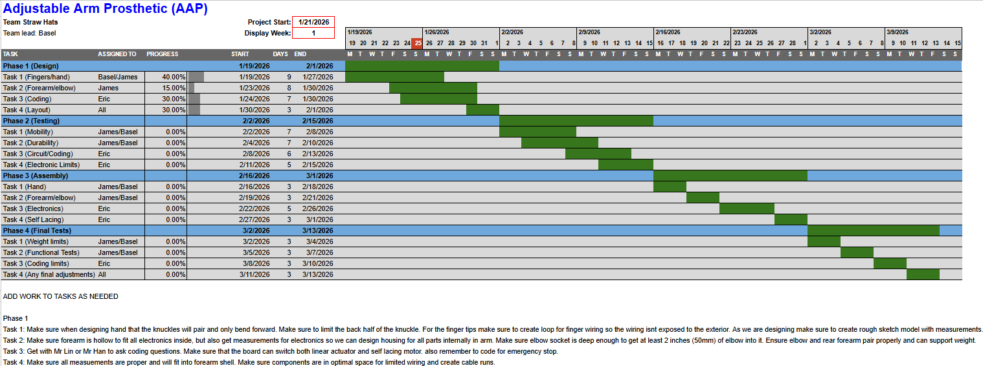
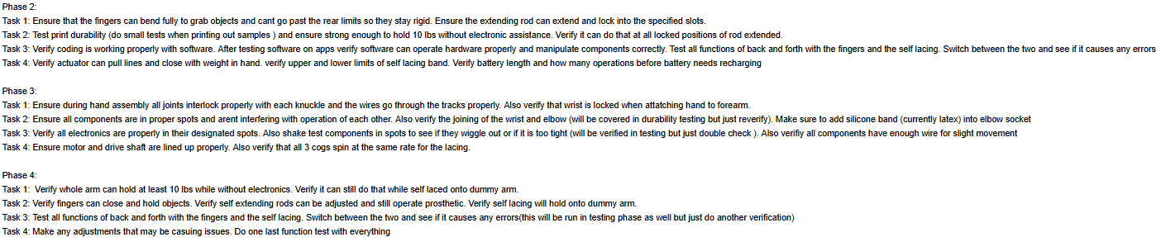

GitHub Link Share and Updates
https://github.com/ecarlos03/Senior_Project.git -Eric/James

Links / Artifacts
https://app.cirkitdesigner.com/project/1fe1960a-15b2-40e8-987d-4e9e13111ca5
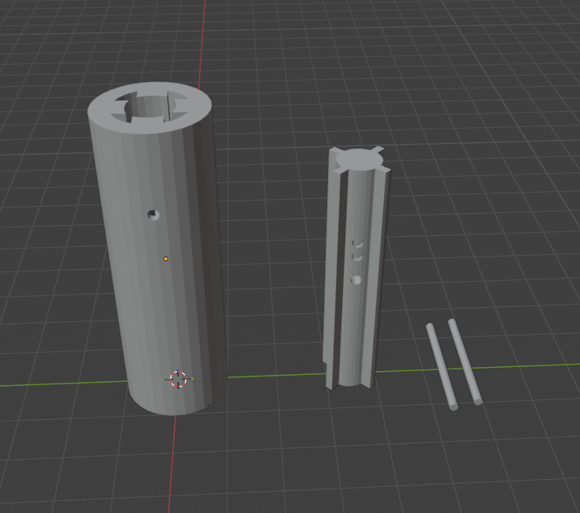 Extending rodV4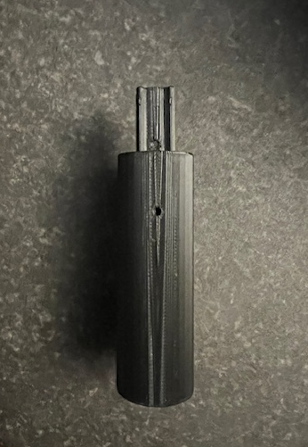 Printed well needs to create a bigger locking pin for the next model.
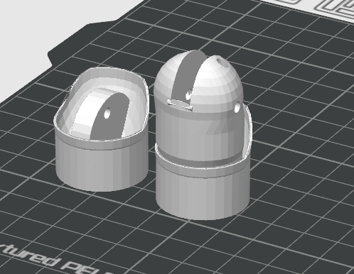 Knuckle V?
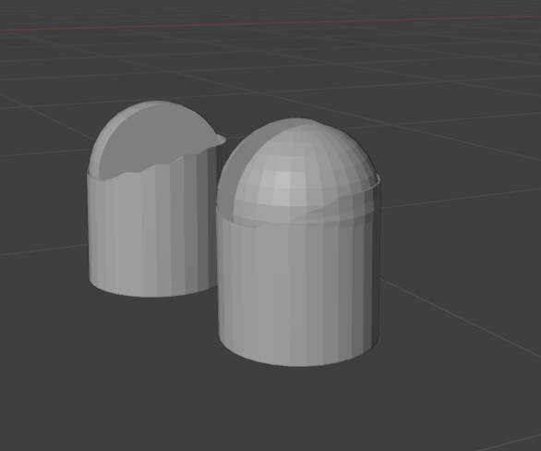

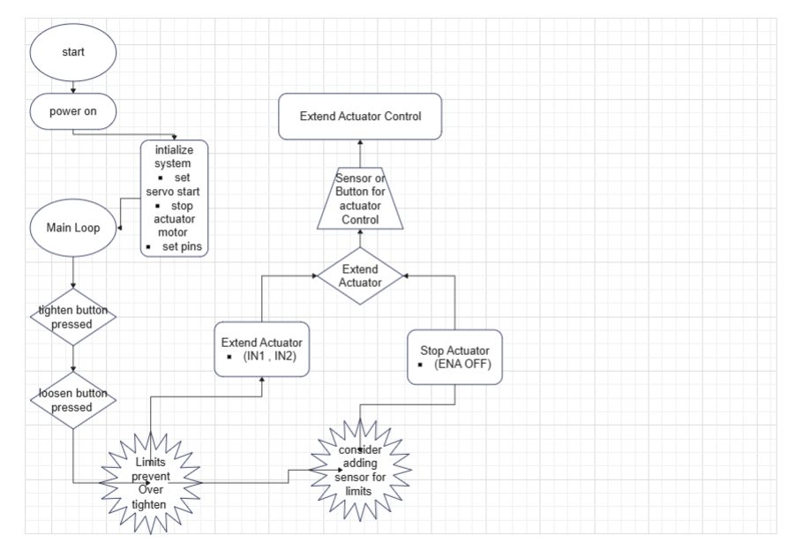
Flow Chart Design
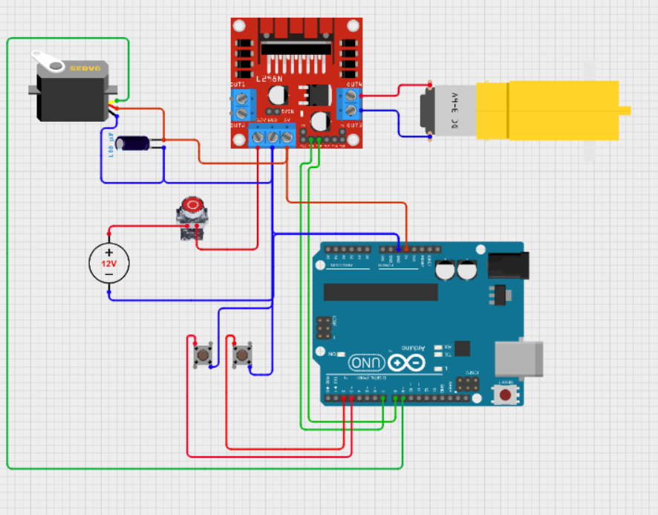
Circuit Design With E-stop and new actuator motor and Dc motor simulating Actuator motor

Dimensions for Electronics: (Keep in mind when designing forearm)
LxWxH
69.088 x 55.118 x 18.034 mm [Battery Pack]
43 x 43 x 28 mm [Motor Driver]
40.7 x 19.7 x 42.9 mm [Micro Server]
68.6 x 53.4 x 18 mm [Arduino]
84 x 55 x 8 mm [Bread Board]
70 x 22 x 18 mm [DC motor]
64.5-74.5mm extension [Actuator Length]

Key Updates / Context
- Initial finger joint designs were found to be too restrictive, limiting motion to ~10°
- Ball-joint based designs are being explored to allow up to 90° of motion while maintaining structural integrity
- Blender modeling focused on creating hollow cylindrical sockets with partial retaining lips to capture the joint ball
- Continued emphasis on internal cable routing to prevent external wear or damage

Discussion Notes
Finger Joint Design
- Ball joint geometry is being implemented to improve finger articulation
- Retaining lips are being designed asymmetrically to allow snap-in assembly while limiting backward motion
- Clearance and tolerances are being evaluated to ensure compatibility with 3D printing
Mechanical Structure
- Telescoping rod design still requires refinement to ensure secure locking under load
- Discussion centered on using pins or mechanical stops to prevent collapse during use
Electronics and Coding
- Circuit simulations continue, with focus on separating actuator and self-lacing controls
- Emergency stop logic remains a key requirement for safety

Decisions
ID | Decision | Owner | Rationale / Notes
D-1 | Move forward with ball-joint based finger joints | Basel / James | Allows a greater range of motion and more natural finger movement
D-2

Action Items
ID | Action | Owner | Due | Priority | Status | Notes / Link
A-1 | Refine ball-joint finger design in Blender | Basel | 2026-01-30 | P1 | In Progress | Focus on motion limits and snap-fit lip
A-2 | Improve the telescoping rod locking mechanism | James | 2026-01-30 | P1 | In progress | Investigate pin-based locking
A-3 | Continue circuit simulation and coding tests | Eric | 2026-02-02 | P1 | In progress | Ensure independent control and E-stop

Risks / Blockers
Finger joint motion limitations
- Impact: Medium
- Mitigation: Transition to ball-joint design with controlled rotation limits
Mechanical locking reliability for the telescoping rod
- Impact: Medium
- Mitigation: Introduce mechanical pins or defined locking slots

Open Questions
How much clearance should be allowed in the ball joint to balance smooth motion and structural strength?
- Owner: Basel
- Target Date: 2026-01-30
How will the extending rods (interior forearm) and outer extension rods (exterior elbow/bicep) connect to the prosthetic?

Next Meeting
Date/Time: 2026-01-31, Time TBD
Proposed agenda:
- Review updated finger joint models
- Evaluate telescoping rod locking revisions
- Check alignment with next milestone goal

